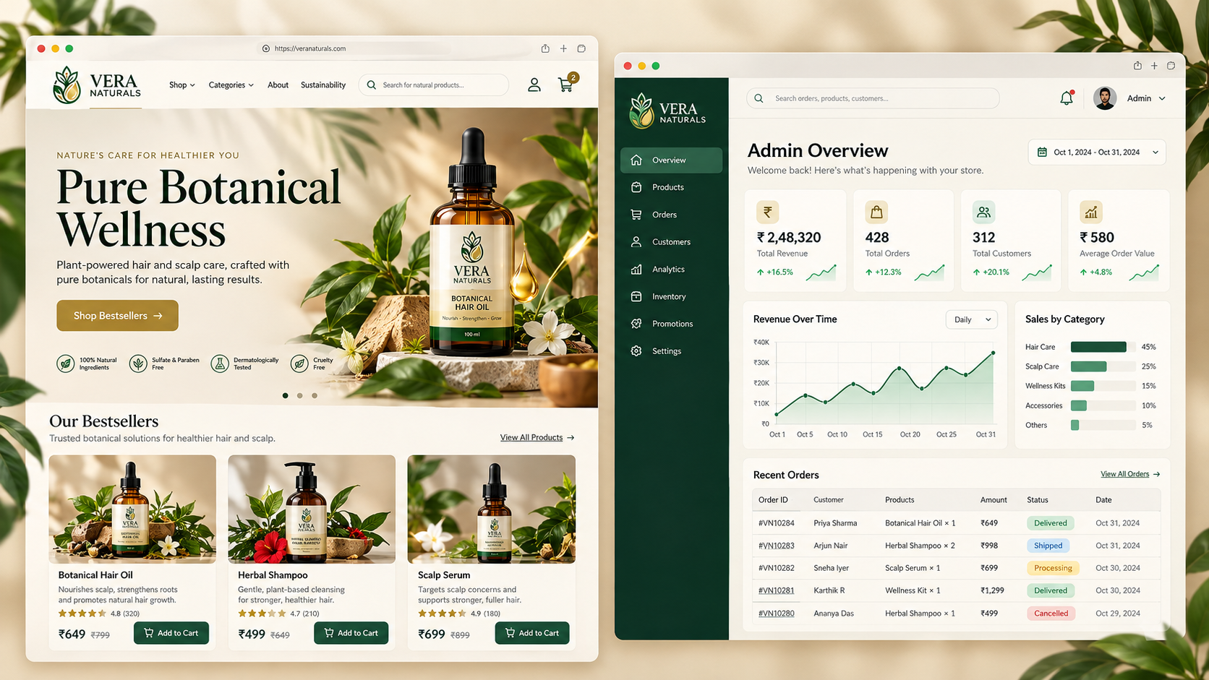

VERA NATURALS — Full-Stack MERN E-Commerce Platform
Your project should be a complete e-commerce application, not just a shopping website. It will have two connected experiences: a premium botanical-product storefront for customers and a professional, interactive Business Intelligence (BI) dashboard for administrators. Both will use the same backend and MongoDB database.
1. Application preview
Here is the initial visual concept for VERA NATURALS, based on your green-and-gold botanical logo and the natural wellness branding you provided.
Storefront + Admin Dashboard · Desktop concept
View preview
This is a static visual mockup, not the running application. The displayed sales figures, customer counts, orders, product prices, and growth percentages are illustrative. The implemented dashboard will fetch actual data from the database.
2. Overall system architecture
React Frontend
Customer storefront · User account · Admin dashboard
HTTPS · Protected REST API
Node.js + Express.js
Authentication · Authorization · Business logic · Payments · Analytics
MongoDB
Users · Products · Inventory · Orders · Payments · Reviews · Analytics data
Payment gateway
Razorpay or another supported gateway, with verified payment webhooks and payment-status reconciliation.
Image storage and email services
Product image hosting, email verification, password resets and order notifications.
3. Customer application features
The customer interface should have the following pages and workflows.
Hair Oil Landing Page by Arshal Ameen on Dribbble
A. Home page and product discovery
Premium landing page, product categories, promotional banners, bestsellers, new arrivals, featured products and search.
Hair Care – Page 2 – Made To Bloom
B. Product catalogue and details
Category and price filters, sorting, pagination, product images, descriptions, ingredients, sizes, available stock, ratings and related items.
E-Commerce Website UI Design for Cosmetics & Beauty Products by Anwer on Dribbble
C. Cart and checkout
Add and remove items, change quantities, calculate shipping, apply coupons, manage delivery addresses and complete payment securely.
Browse thousands of History Order images for design inspiration | Dribbble
D. Customer account
Profile, saved addresses, order history, payment status, order tracking, wishlist, reviews, password change and account settings.
Additional features should include responsive mobile layouts, contact and FAQ pages, shipping and return policies, privacy policy, product availability indicators, empty-cart states and helpful error messages.
4. Authentication and authorization
Authentication determines who the user is. Authorization determines what that user is allowed to do.
Capability | Customer | Admin
Sign up and log in | Yes | Securely provisioned account
View and purchase products | Yes | Yes
Access own profile and orders | Yes | As permitted by admin role
Manage product catalogue | No | Yes
Manage inventory and categories | No | Yes
View all customer accounts | No | Yes
Update order and fulfilment status | No | Yes
View business analytics | No | Yes
Manage coupons and promotions | No | Yes
Manage administrative access | No | Restricted privileged admin
Security implementation
The application should include:
- Secure password hashing using Argon2id or bcrypt.
- Email verification, forgot-password and reset-password workflows.
- Secure sessions or access and refresh tokens stored in appropriately configured HTTP-only cookies.
- Server-side role checks for every protected API route.
- Rate limiting on authentication endpoints and validation of all submitted data.
- Secure account recovery, session revocation, HTTPS and appropriate CSRF protections when cookie-based authentication is used.
- Audit logs for sensitive administrative actions.
Important: Do not allow public registration to assign the admin role. Create the first admin through a controlled setup process, then allow privileged account management through protected admin operations.
5. Professional admin BI dashboard
The admin dashboard is one of the most important parts of this project. It must be connected to the live backend rather than displaying hardcoded sample metrics.
Analytics overview
Interactive reports with date ranges, filters and drill-downs.
Total revenue
Live data
Paid orders, net of recorded refunds
Total orders
Live data
Order count and status breakdown
Customers
Live data
Registered and repeat customers
Inventory
Live data
Low-stock products and stock value
Dashboard visualizations
Revenue trends
Daily, weekly, monthly and custom date ranges; comparisons against previous periods.
Product and category performance
Best-selling products, sales by category, average order value, returns and discounts.
Operations and customer insights
Order fulfilment, cancellations, repeat purchases, new registrations and low-stock alerts.
Use a charting library such as Recharts, with backend aggregation pipelines in MongoDB. Admin tables should support search, sorting, pagination, filters and CSV export.
A conversion-rate metric will require reliable visit, product-view and checkout event tracking; it cannot be derived accurately from orders alone. All financial metrics should have explicit definitions so pending payments and refunds are treated consistently.
Admin management modules
Module | Administrative capabilities
Products | Create, edit, archive and delete products; manage images, pricing, variants and descriptions
Categories | Add and organize product categories
Inventory | Update stock, adjust stock with a reason, inspect low-stock alerts
Orders | Search orders, update fulfilment, manage cancellations and process eligible refunds
Customers | Search accounts, inspect order history, deactivate accounts and manage customer support
Promotions | Configure coupons, discounts, campaigns and date limits
Analytics | Sales, profit estimates where cost data exists, inventory and customer reports
Settings | Store information, shipping rules, tax settings and notification preferences
Admin security | Manage approved admin accounts, permissions and audit logs
Administrative access to customer data should follow the principle of least privilege. Every sensitive change must be authorized by the backend and recorded where appropriate.
6. MongoDB database design
Use separate collections for the main business entities.
Collection | Important information
users | Name, email, password hash, role, verification state, account status
products | Name, SKU, description, category, variants, price, images, stock, status
categories | Name, slug, description, display order
carts | User, product variants, quantities
orders | Order items, price snapshots, address snapshot, totals, payment and fulfilment status
payments | Gateway reference, amount, status, verification and refund records
coupons | Code, discount rules, expiry and usage limits
reviews | Product, customer, rating and review text
wishlists | Customer and saved product references
inventoryMovements | Stock changes, reason, timestamp and administrator
auditLogs | Actor, action, target record, timestamp and relevant change details
analyticsEvents | Product views, cart actions and checkout events where required
Use indexes for frequently queried fields such as email, SKU, category, order date and status. Use database validation and appropriate transaction support for operations that must remain consistent.
7. Backend API structure
The frontend will communicate with Express through a versioned REST API.
API namespace | Example endpoints
/api/v1/auth | POST /register, POST /login, POST /logout, GET /me, POST /forgot-password
/api/v1/products | GET /, GET /:id
/api/v1/categories | GET /
/api/v1/cart | GET /, POST /items, PATCH /items/:id, DELETE /items/:id
/api/v1/orders | POST /, GET /my-orders, GET /:id
/api/v1/payments | Create payment, verify payment and receive payment webhook events
/api/v1/account | Update profile, addresses, password and wishlist
/api/v1/admin/products | Product management operations
/api/v1/admin/orders | Order search and authorized fulfilment changes
/api/v1/admin/users | Customer and administrative account management
/api/v1/admin/analytics | Dashboard KPIs, time series, product performance and reports
/api/v1/admin/inventory | Stock, adjustments and low-stock reports
The /admin routes are not secure merely because the admin pages are hidden from customers. Every request must undergo server-side authentication, permission checks and input validation.
For payments, verify gateway signatures and webhook events, handle duplicate events idempotently, and confirm payment status on the server. Never trust the browser alone to declare an order paid.
8. Recommended frontend pages and routing
/
├── /shop
├── /categories/:slug
├── /products/:slug
├── /cart
├── /checkout
├── /login
├── /signup
├── /forgot-password
├── /account
│ ├── /profile
│ ├── /addresses
│ ├── /orders
│ ├── /wishlist
│ └── /settings
└── /admin
├── /dashboard
├── /products
├── /categories
├── /inventory
├── /orders
├── /customers
├── /promotions
├── /analytics
├── /admins
└── /settings
Use a shared design system with the following proposed visual identity:
VERA NATURALS
Pure Botanical Wellness
Premium, botanical, sophisticated and approachable.
Forest green
#123E30
Botanical gold
#C6A45B
Warm ivory
#F6F0E5
Charcoal
#242824
Recommended frontend tools are React, Vite, TypeScript, React Router, Tailwind CSS or CSS Modules, TanStack Query for API state, and Recharts for analytics.
9. Implementation roadmap
Build the application in phases, with each phase resulting in a testable milestone.
Phase 1 — Foundation and design
Set up the client and server projects, environment configuration, MongoDB connection, design system and shared components. Finalize the catalogue and store policies.
Deliverable: Project foundation
Phase 2 — Authentication and permissions
Build signup, login, email verification, password recovery, profile access, secure sessions and role-based middleware. Create the initial administrator securely.
Deliverable: Protected user accounts
Phase 3 — Storefront and catalogue
Develop responsive home, product listing, category, product details, search, cart, wishlist and customer account pages.
Deliverable: Working product browsing
Phase 4 — Checkout and order management
Implement address handling, server-side price calculations, stock reservation, coupons, payment integration, webhook processing, order tracking and cancellation/refund workflows.
Deliverable: Complete purchase flow
Phase 5 — Admin management and BI
Implement product, stock, order and customer management, backend aggregation APIs, KPI cards, interactive charts, reports and audit logs.
Deliverable: Live admin dashboard
Phase 6 — Testing and deployment
Test permissions, checkout, payment failures, concurrency, responsive layouts, API validation and dashboard calculations. Configure production secrets, logging, database backups, HTTPS and deployment.
Deliverable: Production-ready release
10. Suggested project folder structure
vera-naturals/
├── client/
│ └── src/
│ ├── app/
│ ├── components/
│ ├── layouts/
│ ├── features/
│ │ ├── auth/
│ │ ├── products/
│ │ ├── cart/
│ │ ├── checkout/
│ │ ├── account/
│ │ └── admin/
│ ├── services/
│ ├── hooks/
│ └── types/
├── server/
│ └── src/
│ ├── config/
│ ├── models/
│ ├── routes/
│ ├── controllers/
│ ├── services/
│ ├── middleware/
│ ├── validators/
│ ├── jobs/
│ └── utils/
├── tests/
├── .env.example
├── README.md
└── package.json
Keep frontend UI logic separate from backend business logic. Controllers should stay relatively thin, with services handling business rules such as payment verification, inventory changes, order transitions and analytics calculations.
11. Product catalogue requirements
Your supplied references establish the VERA NATURALS branding and a botanical hair-care direction, but they do not contain a complete, verified product catalogue. Start with a flexible catalogue and enter the confirmed products before launching.
Suggested category | Example product type | Information to store
Hair oils | Botanical hair oil | Volume, ingredients, price, stock and usage instructions
Scalp care | Scalp serum | Volume, ingredients, instructions and warnings
Hair cleansing | Herbal shampoo | Volume, ingredients, directions and suitability
Hair treatment | Hair mask or conditioner | Size, ingredients, directions and product benefits
Wellness kits | Hair-care kit | Included products, bundle price and stock rules
Product examples and all prices shown in the mockup are placeholders, not confirmed products or actual prices. Do not publish ingredient lists, dermatological claims, certification claims or health benefits until the business has verified them.
Each product should support a title, slug, SKU, category, images, variants, price, optional compare-at price, stock quantity, ingredient list, usage instructions, warnings, shipping details, publication status and optional product cost for margin analytics.
12. Testing and completion criteria
The application should only be considered complete once these end-to-end workflows work:
- A customer can register, verify their email, log in and recover their account.
- A customer can browse products, manage their cart, pay securely and see their order history.
- Payment failure or duplicate webhook delivery cannot incorrectly mark an order as paid or charge inventory twice.
- An ordinary customer cannot access administrative APIs by changing a URL or sending a direct HTTP request.
- An admin can create products, update stock, manage orders and inspect customer accounts within authorized permissions.
- Dashboard totals match the underlying order and payment records for the selected date range.
- Search, filters, pagination, charts, reports and mobile layouts work correctly.
- Sensitive data is protected, administrative actions are auditable, and production configuration does not expose secrets.
Recommended build order: start with the database models, authentication and authorization, then build the catalogue and purchase workflow. Once those core records are reliable, connect the BI dashboard to the same backend. This gives you a genuine full-stack application in which the customer storefront, admin tools and analytics all operate on the same source of truth.
